CEIP Ponte dos Brozos
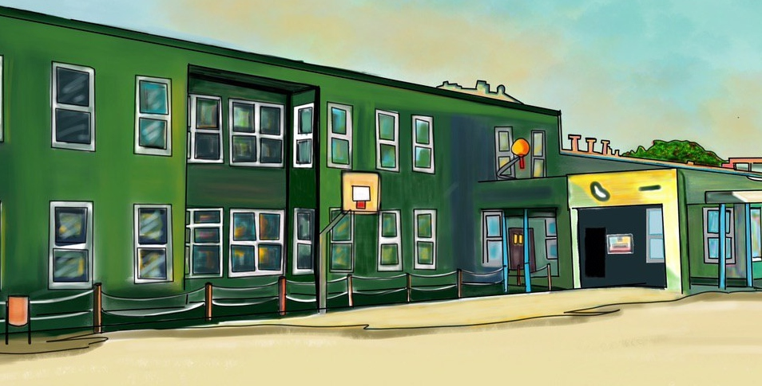

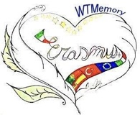
Walking through the memory with immersive technologies
PROJECT:2019-1-ES01-KA229-065937. Walking through the memory with Immersive Technologies
CEIP PONTE DOS BROZOS- ARTEIXO

1.- Virtual Tours 1
2. Superwomen of Arteixo 2
3.- Legends of Arteixo 3
TUTORIALS. 3
Cospaces 3D enviroment 3
360 images Cospaces Edu: 4
Downloading 360 images 4
My360.io 4
Assemblr_Edu 4
Kinemaster video editor 4
Merge Cube 4
Book Creator 5

1.- Virtual Tours

The virtual field trip has become a popular pedagogical strategy for connecting our Erasmus students and teachers to enriching educational experiences from the comfort and safety of the classroom — or home. During the COVID-19 pandemic we have been forced to move to remote learning and find new and innovative ways to deliver curriculum to our students.

Virtual field trips are not limited by distance and, in this pandemic age, eliminate the need for mobility, connect students and do not involve safety concerns. In addition, virtual field trips create enriching, interactive experiences that accommodate students of all learning styles and expose them to diverse perspectives.
“Technology allows students to travel the world, both in time and space,”

Our 2nd and 4th level students created during this school year some projects about their favourite places in our city. They were created with Thinglink and also My360.io

This tour is about our favourite parks:
https://www.thinglink.com/media/1447221184352485379

The river walk of Arteixo is located in the urban area and goes from Loureda to Muiño do Rañal, along the river Bolaños. It is a perfect area for everyone's leisure. The girls and boys of the CEIP Ponte dos Brozos know it and invite you to know it.
https://www.thinglink.com/media/1434586419136823299

In this one, follow the route of the viewpoints and you will enjoy the wonderful landscapes they offer. Don't forget to interact with the people that appear on the tour because they have a lot to tell you.
https://app.my360.io/UJV-VLW

In this tour our students invite you to follow their virtual route and discover some of the most known places. Don´t miss the information shared by the different characters that appear. Also we would like to thank the students, teachers and families for making this virtual tour possible.
https://app.my360.io/ZUA-RRA

The coastal path of Arteixo, better known as the Blue footpath of Arteixo. In the year 2020, there were 68 blue footpaths awards in Spain and we are lucky to have one in our city!

This award values the recovery and protection of the natural environment and its natural, cultural and heritage resources. It also highlights the sustainable development of the coast, constituting a space that favors healthy living habits.

The blue trail is 6.4 kilometers long (one way) and runs along the coast of Arteixo passing by some spectacular beaches with blue flags: Alba, Salsa-Repibelo, Hucha, Valcovo, Combouzas, Barrañan and O Reiro.

The students and teachers of second and fourth grade of Primary Education created a tour with images in 360 degrees to make visible and show this marvel of the municipality.

https://app.my360.io/XZM-DQT

2. Superwomen of Arteixo

International Women’s Day is all about the achievements of women around the world. It’s also a chance to do what you can to make positive changes in women’s lives. Let these real-life heroes inspire you to action.

Our five superwomen don’t wear capes. They don’t fly or have super strength. That’s because we believe all girls are superheroes. And all girls have powers that make them special and can help make the world a better place.

On the occasion of Women's Day, March 8, first graders researched and surveyed the super women of Arteixo, which they consider important in ours lives.
Heritage also shapes people, their experiences, their memories and what better way to learn from our super women! Once we know our school, our environment, we will meet our people.
On the occasion of Women's Day, March 8, first graders researched and surveyed the super women of Arteixo, which they consider important in ours lives.

Heritage also shapes people, their experiences, their memories and what better way to learn from our super women!

https://view.genial.ly/5fef96f2a4c36c0d86fff30f/game-breakout-erasmus-1onivel

3.- Legends of Arteixo

Our coast provides a fascinating insight into the lives of the people that inhabit this coastal region. It is the gateway to A Coruña’s dreaded Costa da Morte or ‘Coast of Death’, which earned its name and reputation due to the shipwrecks that were once common occurrences in this region. It extends from here as far as Finisterre, and includes the towns of Malpica, Muxía, Corme, Laxe, Camariñas, Corcubión and Cee.

This is the version of the boys and girls of 6th grade of Infant Education of CEIP Ponte Dos Brozos about the shipwreck of the fishing boat Genevieve de Galard.
We hope you like it and find it so entertaining that you will never forget what happened on a New Year's Eve many years ago.
https://drive.google.com/file/d/1zflzs-ml1gpjmJaYyvMyTvfsTIx14rOy/view?usp=sharing

TUTORIALS.
https://drive.google.com/drive/folders/14gGnRo2ErgOL7apNZ-jIgxpP5ZdqQ1a5?usp=sharing

Cospaces 3D enviroment

https://drive.google.com/file/d/1Qhbk7oH5i9XEPOUsGI2Ji_NAAtoKxLAv/view?usp=sharing

360 images Cospaces Edu:
https://drive.google.com/file/d/155nyoTorvx2lyLwd3dYvuVeqGf3ORdSB/view?usp=sharing

Downloading 360 images

https://drive.google.com/file/d/1VG7EmTU8jN8YW0w48WznFF3lfbqgfx48/view?usp=sharing

My360.io
https://drive.google.com/file/d/1d-k8-IoR32iiI1IxwJCglevXpkwdQYa3/view?usp=sharing

Assemblr_Edu

https://drive.google.com/file/d/1GvY9qkRCfgWDFrrwVHCJ7wLzXzpjQuyw/view?usp=sharing

Kinemaster video editor

https://drive.google.com/file/d/18769w3uGpcCktfQ_IXrXAegeQyH9SNaL/view?usp=sharing

Merge Cube
https://drive.google.com/file/d/1ea0fFRv7nsqxm_bIIi1TyeVSv2shuQ3o/view?usp=sharing

Book Creator

https://drive.google.com/file/d/1EEHGzUE9MlSGBpn339lQ74YkXg_CZ9JL/view?usp=sharing

